Compiling A Simple C program

Command – vi hello.c



Write the C program

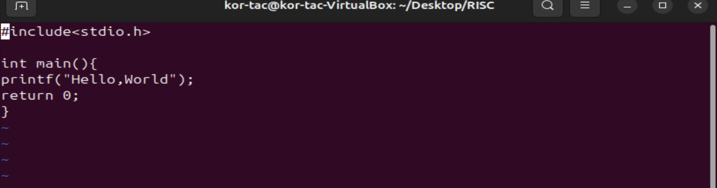

Press I to enter into insert mode

And :w for writing the code

And :q to quite

Command- cat hello.c to view the code

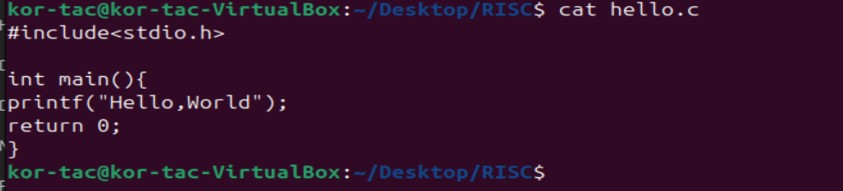

Command - riscv32-unknown-elf-gcc -march=rv32imac -mabi=ilp32 -o hello.elf hello.c --specs=nosys.specs

rv32imac includes:

* I = Base integer
* M = Multiply/divide
* A = Atomic
* C = Compressed



This will create the hello.elf file

Command- file hello.elf

